Program 2: Fruit Classification

Zhao Do

Abstract—This program detects and highlights fruits in a grayscale image by processing the image to separate foreground elements. The fruits are identified, classified, and emphasized. Once a region of a fruit is identified, statistical analysis is performed to classify its type and components.

Classification algorithm

Handling Input
To start off, the user begins by selecting an image from their local device. In the development process, this image shown in Fig. 1 is labeled as the “Original Image.” This image is read twice, one as a grayscale for processing and the other as a color image for displaying output.

Foreground Separation
In order to separate the foreground elements from the background layer, we begin with using Double Threshold algorithms and set the values as 95 and 200 respectively for low threshold value and high threshold value. Afterwards, we perform a series of Dilation and Erosion in order to obtain a clean threshold image, shown in Fig. 2.

Component Identification
The process of component identification is the key to performing following section as it’s an important tool to label each foreground element. For this process, two approaches were utilized, Connected Components using Flood fill algorithm and Connected Components using Union Find. Both methods were utilized throughout this program to ensure that employing either of these would allow us to treat each piece of fruit independently and reference it in the code using distinct labels. The object detection will be using the Connected Component by Flood Gill algorithm while the Stem Detection for bananas will be using Connected Component by Union Find algorithm. When developing the code, one issue were raised while implementing for Connected Component by Union Find where label values were much greater than the uint8 type image size. This was addressed by creating an uint32 type image to handle the processing stage and after equivalent the label values, output it back into a uint8 type image. For displayed purposes, each label has a unique grayscale intensity and is shown in Fig. 3 for Connected Components by Flood Fill and Fig. 4 for Connected Components by Union Find.

Component Analysis & Classification
The process of identification and classification are closely related. In the first step, calculation for each individual component were made regarding their moments, central moments to calculate their eigenvalues, semi major axis, semi minor axis, eccentricity and direction. Afterwards, classification were made based on the calculated values above. Using Table. 1 below, fruits were classified based on their calculated features. For example, to detect banana, the eccentricity would need to be greater than 0.8. To differentiate between tangerine and apple, comparation of their areas or semi major and semi minor axis length were conducted. Tangerine needs to have larger area. The methodology is limited to this specific angle of the image and certain types of fruit; however, it provides a solid foundation for developing machine learning algorithms to assist the computer in making judgment classifications of these types of fruit in the future.

Subcomponent Identification & Analysis
In this section, the focus is on how to detect subcomponents of the identified type of object, specifically, the banana stem in this case. Once the object was classified as a banana from the connected component step, a processed image was created only for identified banana and called “bananas” in the processing code, from the original image. Starting with eroding this image until the banana stem is completely removed and dilate it back the same number of times to get the original size of the banana. This image is called “banana body” in the processing code. A few adjustments were also added by more dilation and erosion to ensure the desired shape and size for the banana body. A “banana stem” image is now able to be created by simply subtracting the “banana body” image from the “banana” image. Afterwards, Connected Components by Union Find were used in this step to identify the banana stem regions. This process is repeated for each detected banana. The stem detection worked well for both fruit1.bmp and fruit2.bmp tests image. The final images for both test images can be seen in Fig 5. and Fig. 6.

Labelling Components & Axis
Once all components and subcomponents were identified, Wall Following algorithm were used to get an array for each of the components and subcomponents. For banana element, wall following algorithm were used for the “banana body” image and “banana stem” instead of the original classification. A colors arrays were also made in order to display and distinguish identified objects. For axis of each component, log scale in respect to the component’s area were used in order to display scaled axis for each component. This is done along with plotting axis over each component. The results can be observed in Fig 5. and Fig. 6.

Results
Fruit | Area | Eccentricity | Eigen 1 | Eigen 2
Top banana | 4949 | 0.81 | 9.91e6 | 1.13e6
Top apple | 3001 |  | 7.82e5 | 6.61e5
Middle tangerine | 5885 | 0.27 | 2.98e6 | 2.55e6
Right tangerine | 5843 | 0.17 | 2.79e6 | 2.64e6
Lower banana | 4660 | 0.82 | 9.07e6 | 9.32e5
Lower apple | 3192 | 0.2 | 846792.02 | 781235.85
Table. 1 Descriptive statistic for fruit1.bmp components

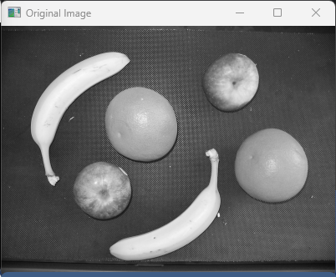
Fig. 1 Input Image (fruit1.bmp)

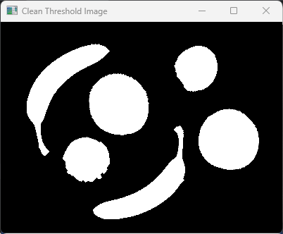
Fig. 2 Clean Threshold Image

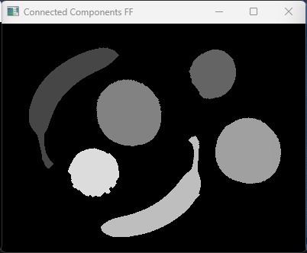
Fig. 3 Connected Components using Flood fill image
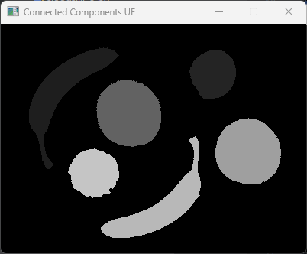
Fig. 4 Connected Components using Union Find image

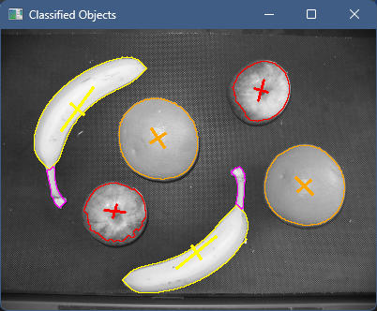
Fig. 5 Fruit1.bmp output image

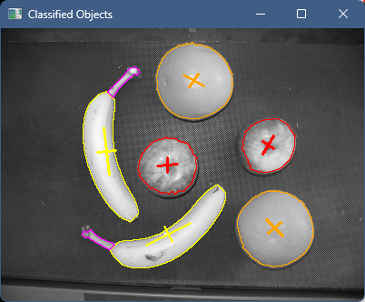
Fig. 6 Fruit2.bmp output image

